FACULTY EVALUATION
Programme Name: Social Entrepreneurship Program (SEP)- Growth MASTERCLASS Module 1 Kenya (2nd March 2026 - 6th March 2026)
Session: Reflect on Vision and Mission
Faculty Name: Dr. Cathy Mbidde
No. of Respondents: 13
No. of Participants: 13
Evaluation Parameter | (%) Individual Score | (%) Programme Average
Punctuality (Commencement and Completion of Sessions) | 91 | 93
How well do you understand the core concepts presented? | 89 | 95
Rate your confidence in applying the new skills learnt | 85 | 88
Degree of Faculty preparedness for the sessions | 95 | 95
Content and methodology of the program | 94 | 96
Quality of class and group discussions | 88 | 89
The information presented in the course is relevant to my work (ministry) | 95 | 97
Average scores | 91 | 93

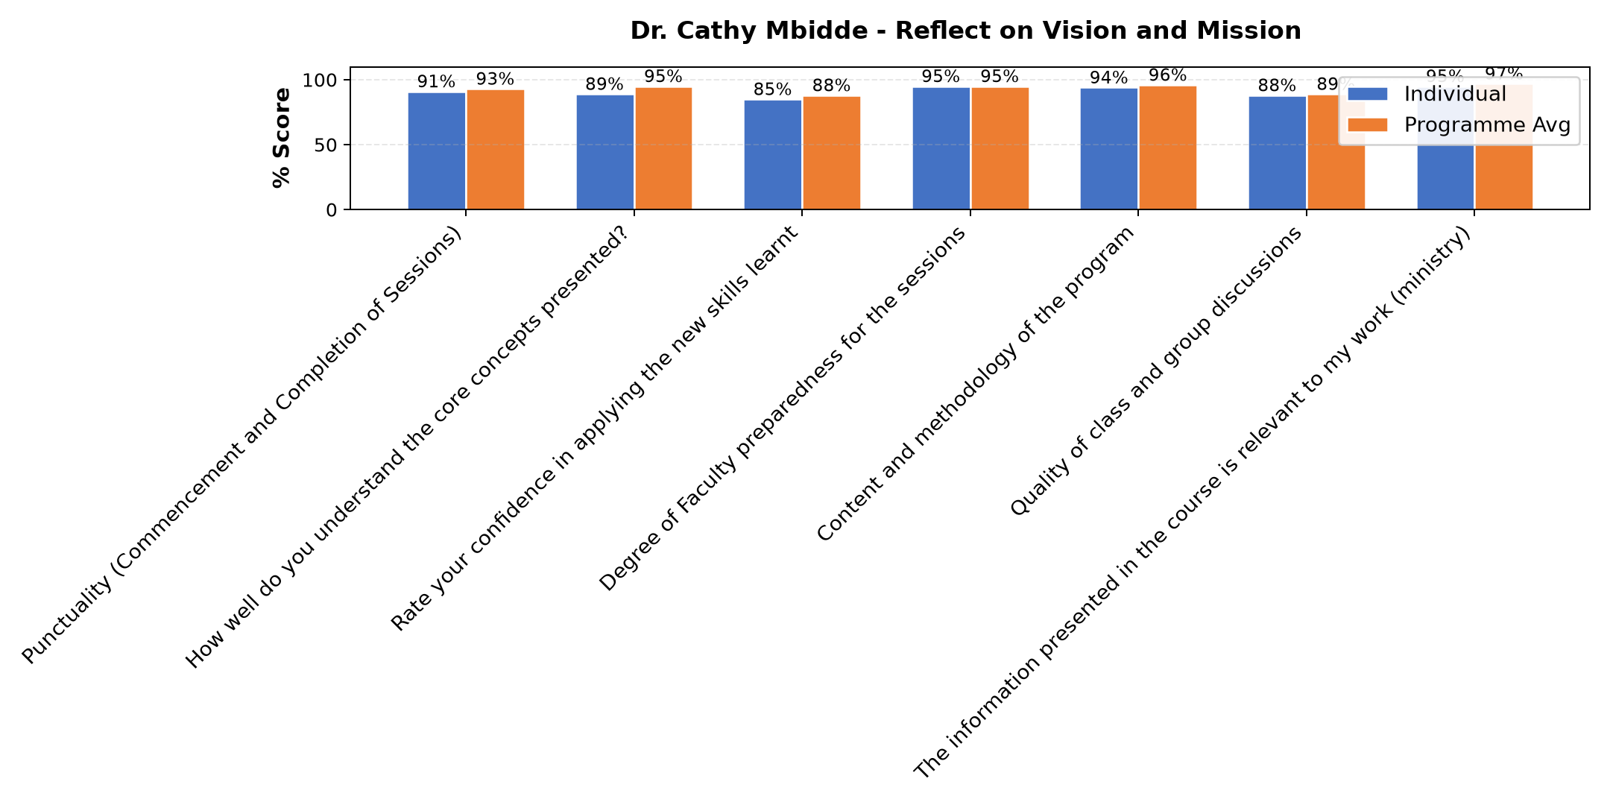

Comments & Feedback
- • Challenges in funds since the strategic plans laid as per the mission ,vision, goals and objectives for the next 3 years might fail due to delayed payments from tenants and also transfers hinders me to apply the knowledge on the project at hand hence you find that before you accomplish the task laid across for a specific period ,a new person comes in with no vision for the same project hence diverging attention or focus on other project which she is more talented in.
- • If the social enterprise is not well structured.
- • Lack of confidence to face the reality on dealing with the people in the community
- • Deeper knowledge of the core values related to the charism
- • Internal factors affecting the social enterprise including constant changes in the management
- • Finances
- • No barriers. Will do my best to apply what I learnt.
- • Lack of resources
- • Maybe If our goals and mission are not well stated If I have not internalized them.
- • Lack commitment maybe of which it won't prevent.
- • The transfers that bring new members who might take time to understand or might not be willing.
SUBMITTED THROUGH:
SBS Evaluation Automation System

